Dungo, Adrian Jeferson T. NW – 301
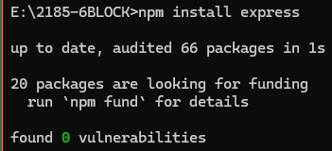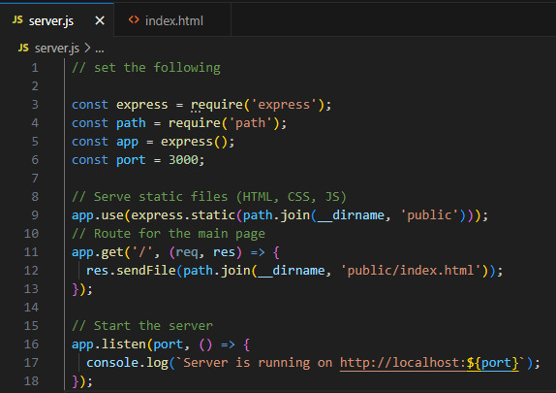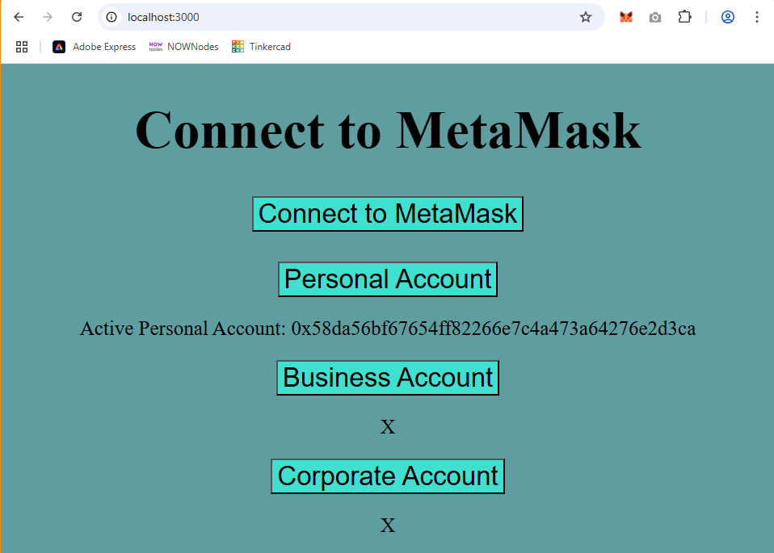
This website has a simple design with a simple functionality of connecting a MetaMask account and getting its account address. I only got the personal account option to work because we only created one account in this activity. But, the website can update and display up to three accounts which are personal, business, and corporate.

